The Influence of Quantity Surveyor Competence on Construction Project
Success in Bali Province

Eka Marawitari*, A.A.Gde Agung Yana, Anak Agung Diah Parami Dewi
Universitas Udayana, Indonesia
Email: ekamarawitari@gmail.com*, agungyana@unud.ac.id, anakagungdewi@unud.ac.id

Keywords: | ABSTRACT
Quantity Surveyor; Competence; Construction Project Success; Cost Performance; Schedule Performance; Human Resource Management, SEM-PLS | The success of a construction project is closely linked to the project's ability to meet its cost and schedule targets. In private-sector building projects in Bali Province, cost deviations and schedule delays remain common, particularly in villa, hotel, resort, and similar commercial developments. Quantity Surveyors (QS) play an important role in cost control through quantity measurement, cost estimating, the preparation of Bills of Quantities, contract administration, progress valuation, variation order management, cost reporting, and final account preparation. This study examines how the competence of Quantity Surveyors contributes to construction project success, particularly in relation to cost and time performance. It also investigates whether human resource management (HRM) can strengthen the relationship between QS competence and project outcomes. A quantitative method was employed, with data analysed through Structural Equation Modelling–Partial Least Squares (SEM-PLS). The instrument was validated using the Content Validity Index (CVI), tested through a pilot study, and subsequently used for the main data collection involving 103 respondents. The findings show that QS competence has a positive and significant effect on project success. However, HRM was not found to moderate the relationship between QS competence and project success. These findings indicate that both QS competence and HRM independently support project success, but that HRM is more appropriately understood as a direct influencing factor rather than as a moderating variable.

INTRODUCTION
The construction industry is a highly complex and high-risk sector involving numerous stakeholders, resources, work stages, and project constraints that must be met. In general, a construction project is regarded as successful when it meets the planned cost, time, and quality requirements. These three aspects, commonly known as the triple constraint, are frequently used to assess project performance (Soeharto, 1999; PMI, 2013). In actual construction practice, cost overruns and schedule delays remain common and may disrupt the project's planned progress (Borse & Khare, 2016; Omran et al., 2023).
In private-sector building projects in Bali Province, cost and schedule control are especially important given the large number of villas, hotels, resorts, and similar commercial developments. These projects generally involve complex designs, intensive coordination, and tight completion targets, and therefore require accurate cost planning, clear documentation, orderly management of work changes, and effective coordination (Ohag et al., 2023). Cost and schedule performance are also widely used as indicators of project success because they are relatively objective and measurable (Takim & Akintoye, 2002; Borse & Khare, 2016).
In building construction projects, Quantity Surveyors are typically involved from the early cost planning stage through to final account preparation. Their work commonly includes preparing estimates, measuring work quantities, reviewing Bills of Quantities, supporting tender and contract documentation, checking progress claims, assessing variation orders, and preparing cost reports. As these tasks are closely related to both cost control and project progress, the role of the Quantity Surveyor is important in helping projects achieve their cost and schedule targets (Rahmayanti & Sihombing, 2020; Wiharja & Ratnayanti, 2022; Theddy & Pranoto, 2024).
The role of a Quantity Surveyor requires more than technical knowledge in measurement and cost estimation. In daily project practice, a QS also deals with contract matters, progress monitoring, work variations, and project administration. These responsibilities demand managerial ability, and communication, coordination, and negotiation skills are essential given that QS work involves numerous project stakeholders. The competency standard for Quantity Surveyors in Indonesia refers to SKKNI, while RICS is commonly used as an international benchmark (SKKNI, 2011; RICS, 2018). This demonstrates that QS competence must continue to be developed in line with the increasing complexity of construction projects (Shafiei & Said, 2008; Yap et al., 2022; Hansen et al., 2023).
In addition to competence, the effective performance of the Quantity Surveyor function may also be influenced by human resource management. HRM encompasses compensation, task allocation, workload, recognition, training, career development, work environment, and performance evaluation. HRM practices are associated with project performance because construction projects depend heavily on the capability and performance of professional personnel (Wai Yee, 2015; Ghattas et al., 2022). Factors such as salary, workload, recognition, and career development also affect the performance of construction professionals (Egemen, 2024).
Previous studies have examined professional competence, project success, the role of Quantity Surveyors, and HRM. However, studies on competence have largely focused on Project Managers, while studies on Quantity Surveyors have tended to address roles and functions, with relatively few testing the influence of QS competence on project success within a structural model. Furthermore, HRM is more commonly positioned as a factor affecting performance rather than as a moderating variable that strengthens or weakens the relationship between QS competence and project success (Agsarini, 2015; Sasongko et al., 2017; Ghattas et al., 2022).
The novelty of this study lies in several key aspects. First, this study tests QS competence as a multidimensional construct — encompassing technical, managerial, and interpersonal competence — as an influence on project success, rather than simply identifying required competencies. Second, this study positions HRM as a moderating variable, examining whether HRM practices strengthen or weaken the relationship between QS competence and project success. Third, this study employs SEM-PLS, an advanced statistical method appropriate for testing complex relationships involving latent variables and second-order constructs. Fourth, this study focuses specifically on private-sector building projects in Bali Province, providing contextual insights relevant to tourism-driven construction markets. Fifth, this study measures project success in terms of cost and schedule performance, using objective indicators directly influenced by Quantity Surveyor activities.
On this basis, this study aims to analyse the influence of Quantity Surveyor competence on construction project success in terms of cost and schedule performance in private-sector building projects in Bali Province. The quality aspect remains part of the study context, although it is treated as a technical requirement already specified in contract documents, specifications, working drawings, and work acceptance criteria (Rad & Khosrowshahi, 1998; NATSPEC, 2023). The novelty of this study lies in testing QS competence as a multidimensional construct influencing project success, with HRM as a moderating variable, in the context of private-sector building projects in Bali Province. This study does not formulate explicit hypotheses; instead, it employs a conceptual framework to address the research objectives through SEM-PLS.
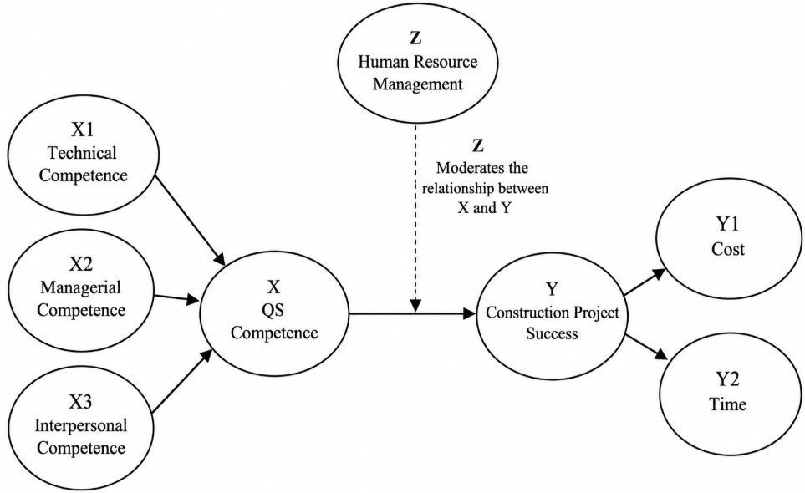
Figure 1. Research Conceptual Framework

METHOD
A quantitative approach was adopted in this study, and SEM-PLS was used to test the relationships proposed in the research model. The method was suitable for this research because it can examine latent variables, multidimensional constructs, and moderation effects within a single model (Hair et al., 2019, 2022). This study was carried out on private-sector building projects in Bali Province, such as villas, hotels, resorts, and similar commercial developments. A purposive sampling method was used to select respondents who were considered relevant to the study. The respondents included Quantity Surveyors, Project Managers, and Site Engineers with direct experience in cost and schedule control. Each respondent had at least three years of work experience and had previously been involved in private-sector building projects in Bali.
The research instrument was a closed-ended questionnaire using a 1-5 Likert scale. The Likert scale was used to measure respondents' perceptions and assessments of the research statements (Budiaji, 2013). The instrument was developed based on three main variables: QS competence, project success, and HRM. QS competence was treated as a second-order construct formed by technical, managerial, and interpersonal competence. Project success was also treated as a second-order construct formed by cost success and schedule success. HRM was measured as a direct construct through indicators related to compensation, workload, recognition, training, work environment, and performance evaluation. The operational summary of the variables is presented in Table 1.

Table 1. Operational Summary of Research Variables
Variable | Dimension | Number of Indicators | Main Sources
QS Competency | Technical, Managerial, Interpersonal | 15 | (SKKNI, 2011; Dada, 2014; Hansen et al., 2023)
Project Success | Cost and Time | 10 | (Takim and Akintoye, 2002; PMI, 2013; Borse and Khare, 2016; Omran et al., 2023)
HR Management | Direct Construct | 10 | (Agsarini, 2015; Wai Yee, 2015; Sasongko et al., 2017; Ghattas et al., 2022; Egemen, 2024)
The instrument was validated by six experts using the CVI to assess item relevance (Polit and Beck, 2006; Yusoff, 2019). A pilot test was then conducted with 30 respondents to assess the initial validity and reliability of the instrument. This number is considered adequate for the early stage of instrument development (Johanson and Brooks, 2010). The main data were obtained from 103 respondents.
Data analysis was conducted using a two-stage approach because the model included second-order constructs. In the first stage, the first-order constructs were evaluated using outer loading, AVE, Composite Reliability, Cronbach's Alpha, and discriminant validity. In the second stage, latent scores from the first-order dimensions were used to form the second-order constructs, namely QS competence and project success. After the measurement model met the required criteria, the analysis continued with the evaluation of the structural model using path coefficients, R-square, effect sizes, and bootstrapping. The final analysis was a moderation test to assess the role of HRM in the relationship between QS competence and project success (Hair et al., 2019, 2022).
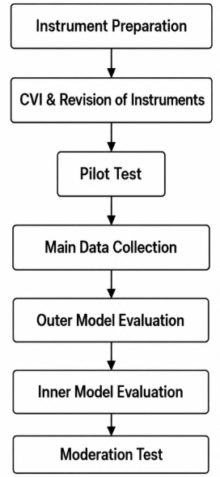
Figure 2. Research and Data Analysis Stages

RESULTS AND DISCUSSION
Respondent Characteristics
The main study involved 103 respondents, all of whom were practitioners who had been, or were currently, involved in cost and schedule control for private-sector building projects in Bali Province. Most respondents were male (79 people, 76.7%), while female respondents totaled 24 (23.3%). By age, respondents were dominated by the 31-40 age group, with 68 people (66.0%), followed by the 25-30 age group with 25 people (24.3%), and the 41-50 age group with 10 people (9.7%).
Based on work experience, respondents with 11-15 years totaled 33 people (32.0%), while those with more than 15 years totaled 32 people (31.1%). Respondents with 3-5 years of experience totaled 21 people (20.4%), and those with 6-10 years of experience totaled 17 people (16.5%). Based on position, the respondents comprised 48 Quantity Surveyors (46.6%), 33 Site Engineers (32.0%), and 22 Project Managers (21.4%).
Villa projects were the most common project type among the respondents, involving 39 respondents or 37.9% of the total sample. Most project locations were in Badung Regency, reported by 47 respondents or 45.6%, followed by Gianyar with 20 respondents or 19.4%, and Denpasar with 19 respondents or 18.4%. Overall, this profile suggests that the respondents were relevant to the scope and context of the research.

Table 2. Characteristics of Main Study Respondents
Characteristic | Dominant Category | Frequency | Percentage
Gender | Male | 79 | 76.7%
Age | 31–40 years | 68 | 66.0%
Work Experience | 11–15 years | 33 | 32.0%
Highest Education Level | Bachelor’s Degree | 75 | 72.8%
Position | Quantity Surveyor | 48 | 46.6%
Project Type | Villa | 39 | 37.9%
Project Location | Badung | 47 | 45.6%

Instrument Validation and Pilot Test
Content validation was carried out by six experts with 15 to 19 years of work experience. The CVI results showed that all statement items met the content validity criteria. Of the 35 statement items, 31 obtained an I-CVI value of 1.00, while four items obtained an I-CVI value of 0.83. The lowest I-CVI value still met the minimum threshold of 0.78 for six experts. The S-CVI/Ave value of 0.98 also indicated good overall content validity.
Before the questionnaire was used in the main survey, it was first tried out with 30 respondents. This step was carried out to see whether the statements were understandable and whether the instrument was consistent enough for further data collection. At the pilot stage, 30 completed questionnaires were used to screen the research instrument before it was applied in the main survey. The 30 pilot-test responses were used to check the questionnaire before it was distributed in the main survey. Item validity was reviewed by correlating each item score with the total questionnaire score using the Pearson Product-Moment correlation, Cronbach’s Alpha, with the calculation carried out in Microsoft Excel, internal consistency of the instrument (Taherdoost, 2016; Utami et al., 2023; Ina Marthiani, 2024). Overall, the pilot test yielded acceptable results, with 34 of 35 items meeting the validity criterion. The only item that required attention was X2.1, which recorded an r-value of 0.303, below the r-table value of 0.361. Even so, the item was not removed because it still reflected the managerial competence of a Quantity Surveyor. The statement was therefore rewritten to make it clearer and easier for respondents to interpret.
The reliability test showed that all dimensions and variables had Cronbach's Alpha values above 0.70. The Cronbach's Alpha value for technical competence was 0.858, managerial competence 0.861, interpersonal competence 0.886, cost success 0.840, schedule success 0.912, and HRM 0.922. These results show that the instrument was reliable and suitable for use in the main data collection.

Table 3. Summary of Instrument Validation and Pilot Test
Stage | Main Result | Decision
Number of Experts | 6 experts | Adequate
Number of Items | 35 items | All items were assessed
I-CVI | 0.83–1.00 | Valid
S-CVI/Ave | 0.98 | Good content validity
Pilot Test | 30 respondents | Adequate
Valid Items | 34 out of 35 | Majority valid
Revised Item | X2.1 | Revised, not removed
Cronbach’s Alpha | 0.840–0.922 | Reliable

Measurement Model Evaluation
The measurement model was assessed at two levels: the first-order constructs and the second-order constructs. In the first-order measurement model, all indicators showed outer loading values higher than 0.70. The outer loading range for technical competence was 0.904-0.940, managerial competence 0.732-0.910, interpersonal competence 0.846-0.873, cost success 0.806-0.906, schedule success 0.833-0.912, and HRM 0.787-0.877. These values met the convergent validity criteria because the recommended outer loading value is generally above 0.70. The measurement results met the recommended standards. Each construct had an AVE value greater than 0.50, which supports convergent validity. The reliability indicators also showed acceptable results, as both Composite Reliability and Cronbach’s Alpha exceeded 0.70. For discriminant validity, the HTMT assessment did not show any issue because the highest value was 0.887, still below the 0.90 limit. Based on these results, the reflective measurement model is acceptable according to the SEM-PLS criteria proposed by Hair et al. (2022).
For the second-order constructs, QS competence was formed by technical, managerial, and interpersonal competence. The loading values of these dimensions were 0.823, 0.847, and 0.959, respectively. Project success was formed by cost success and schedule success, with loading values of 0.919 and 0.900. These results indicate that the measurement model met the validity and reliability criteria (Hair et al., 2019).

Table 4. Reliability and Convergent Validity of First-Order Constructs
Construct | Cronbach’s Alpha | Composite Reliability | AVE | Decision
Technical Competency | 0.954 | 0.965 | 0.845 | Valid and Reliable
Managerial Competency | 0.928 | 0.942 | 0.701 | Valid and Reliable
Interpersonal Competency | 0.827 | 0.896 | 0.742 | Valid and Reliable
Cost Success | 0.923 | 0.942 | 0.766 | Valid and Reliable
Time Success | 0.914 | 0.936 | 0.745 | Valid and Reliable
HR Management | 0.957 | 0.962 | 0.719 | Valid and Reliable

Table 5. Second-Order Construct Measurement Results
Second-Order Construct | Forming Dimension | Dimension Outer Loading | Decision
QS Competency | Technical Competency | 0.823 | Valid
QS Competency | Managerial Competency | 0.847 | Valid
QS Competency | Interpersonal Competency | 0.959 | Valid
Project Success | Cost Success | 0.919 | Valid
Project Success | Time Success | 0.900 | Valid

Structural Model Evaluation
The R-square value of 0.623 indicates that 62.3% of the variation in project success can be explained by QS competence, HRM, and their interaction effect. In other words, the model has a moderate to strong ability to explain project success. The f-square analysis showed that QS competence contributed the most to the model, with a value of 0.540, which represents a large effect. HRM and the moderation effect made smaller contributions, with f-square values of 0.089 and 0.044. These two values fall into the small-effect category based on the SEM-PLS criteria proposed by Hair et al. (2022).
The results indicate that QS competence and HRM both contribute directly to project success. Among the two, QS competence showed the stronger effect, while HRM had a smaller but still significant contribution. However, the interaction term between QS competence and HRM was not statistically significant. This means that HRM did not change the strength of the relationship between QS competence and project success, but worked more as an independent factor supporting project outcomes.

Table 6. Structural Model Evaluation Results
Evaluation Measure | Value | Interpretation
R-square of Project Success | 0.623 | Moderate toward strong
f-square of QS Competency | 0.540 | Large effect
f-square of HR Management | 0.089 | Small effect
f-square of Moderating Effect | 0.044 | Small effect

Before testing the significance of the relationships through bootstrapping, the PLS Algorithm was first used to obtain the path coefficients, R-square value, and loadings of the second-order constructs, as shown in Figure 3.
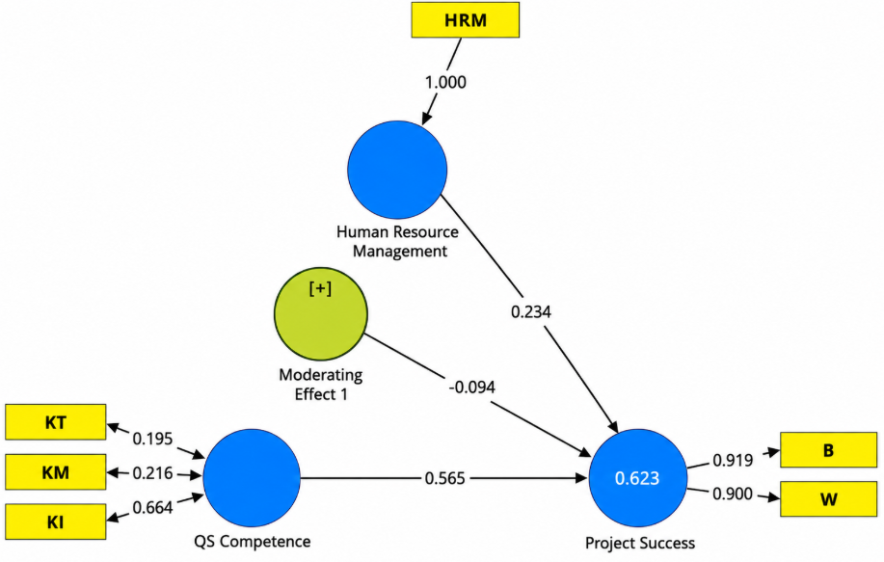
Figure 3. Stage 2 PLS Algorithm Structural Model Estimation
After the path coefficients were obtained through the PLS Algorithm, the next step was to test the significance of the relationships between variables using bootstrapping. This test was used to determine whether the direct effects and the moderating effect in the model were statistically supported. The results of the relationships between variables are presented in Table 7.
Table 7. Results of Relationships Between Variables
Relationship Between Variables | Coefficient | T-statistic | P-value | Decision
QS Competency → Project Success | 0.565 | 5.624 | <0.001 | Significant
HR Management → Project Success | 0.234 | 2.852 | 0.004 | Significant
QS Competency × HR Management → Project Success | -0.094 | 0.980 | 0.327 | Not Significant

The results show that QS competence has a positive and significant effect on construction project success. This finding indicates that the QS's ability to manage quantities, costs, progress, work changes, and contract administration plays an important role in achieving project cost and schedule targets. This result is consistent with Rahmayanti and Sihombing (2020), Wiharja and Ratnayanti (2022), and Theddy and Pranoto (2024), who explain that QS competence supports cost control, contract administration, progress valuation, variation order management, cost reporting, and final account preparation.
This study views QS competence as a combination of technical, managerial, and interpersonal abilities. Technical competence helps ensure more accurate cost estimates and better cost control. Managerial competence is needed to handle project documents, monitor progress, manage variation orders, and complete administrative processes. Interpersonal competence is also important because QS duties involve communication, coordination, and negotiation with project stakeholders. These three dimensions together indicate that the QS has a wider professional role in supporting project success. As project requirements become more complex, the competence of Quantity Surveyors needs to be developed accordingly. This argument is also reflected in the studies of Shafiei and Said (2008), Yap et al. (2022), and Hansen et al. (2023).
The results also show that HRM has a positive and significant effect on project success. This finding indicates that company support for project professionals can help achieve project cost and schedule targets. Such support includes clear task allocation, proportional workload, appropriate compensation, recognition, training, a supportive work environment, and objective performance evaluation. This result supports Wai Yee (2015), Ghattas et al. (2022), and Egemen (2024), who state that HRM practices are related to project performance and the performance of construction professionals.
The moderation results suggest that HRM did not alter the relationship between QS competence and project success. Although the interaction coefficient was negative, this value should not be interpreted as evidence that HRM weakens the relationship, since the effect was not statistically significant. In other words, the data do not support the role of HRM in strengthening or weakening the influence of QS competence on project success. A similar pattern was reported by Ahmad et al. (2023), where some organizational factors remained relevant to the model but did not necessarily operate as moderating variables.
This result can be understood through the temporary and complex nature of projects, which involve many parties. Belout and Gauvreau (2003) explain that the influence of HR factors in a project context is not always easy to measure because HR functions may be distributed across various roles, organizational structures, project stages, project risks, and cost and schedule constraints. Therefore, HRM remains important for projects, but its role does not always appear as a condition that changes the strength of the relationship between professional competence and project success.
The non-significant moderation finding may also be explained by the strong direct effect of QS competence on project success. When QS competence already makes a large contribution, variation in HRM may not be sufficient to change the main relationship. Previous studies also show that moderation effects in projects are highly dependent on context, variable type, and project characteristics. A non-significant moderation effect does not necessarily weaken the relevance of the model, as moderation often depends on the specific project context. Zaman et al. (2019) showed that contextual project factors may even create a negative moderating effect between leadership and project success. Thuy and Anh (2024) further explain that relationships among project variables may vary depending on the boundary conditions of the project. From this perspective, the non-significant moderation effect in the present study can still be viewed as a reasonable empirical finding.
Overall, project cost and schedule success in this study were explained more by the direct effects of QS competence and HRM. HRM remains an important factor, but the data did not show its role as a moderator. The remaining variation in project success may be explained by other factors outside the model, such as project complexity, the quality of design documents, decision-making systems, technology support, cross-disciplinary coordination, and company policies on project control.

CONCLUSION
QS competence has a positive and significant effect on construction project success in terms of cost and schedule performance. The technical, managerial, and interpersonal competence of QS professionals supports cost control, progress valuation, contract administration, variation order management, cost reporting, and final account preparation.
HRM has a positive and significant effect on project success. Company support through task allocation, proportional workload, compensation, recognition, training, work environment, and performance evaluation is an organizational factor that supports achieving project cost and schedule targets.
This study is limited to private-sector building projects in Bali Province, uses perception-based respondent data, and measures project success only in terms of cost and schedule. It also does not include other factors that may influence project success, such as project complexity, design document quality, decision-making systems, technology support, cross-disciplinary coordination, and company policies.
Future studies may expand the research object to different project types and regions. Further research may also test other variables as moderators or predictors, such as project complexity, technology support, project information systems, organizational culture, top management support, project flexibility, or project visibility.

REFERENCES
Agsarini, I. (2015). Pengaruh faktor internal dan eksternal proyek terhadap kinerja proyek konstruksi di Provinsi Kalimantan Selatan.
Ahmad, M. K., Abduhamid, A. B., Wahab, S. A., & Nazir, M. U. (2023). Can the project manager’s transformational leadership lead to project success? Empowerment, goal clarity, and CR leadership. International Journal of Information Technology Project Management, 14(1). https://doi.org/10.4018/IJITPM.326982
Borse, M., & Khare, P. (2016). Analysis of cost and schedule overrun in construction projects. IJISET–International Journal of Innovative Science, Engineering & Technology, 3.
Budiaji, W. (2013). Skala pengukuran dan jumlah respon skala Likert. Jurnal Ilmu Pertanian dan Perikanan, 2(2), 125–131.
Dada, J. O. (2014). A principal component analysis of skills and competencies required of quantity surveyors: Nigerian perspective. Organization, Technology and Management in Construction: An International Journal, 6(2), 1040–1047. https://doi.org/10.5592/otmcj.2014.2.5
Egemen, M. (2024). Assessing the individual effects of different job satisfaction facets on the job performance of qualified employees in the unique conditions of the construction industry. Ain Shams Engineering Journal, 15(7). https://doi.org/10.1016/j.asej.2024.102960
Ghattas, M. S., Bassioni, H. A., & Gaid, E. F. (2022). Human resources management influence on projects performance: A study of contractors professionals working on construction projects in Egypt. IOP Conference Series: Earth and Environmental Science, 1056(1).
Hair, J. F., Hult, G. T. M., Ringle, C. M., & Sarstedt, M. (2022). A primer on partial least squares structural equation modeling (PLS-SEM) (3rd ed.). Sage Publications.
Hair, J. F., Risher, J. J., Sarstedt, M., & Ringle, C. M. (2019). When to use and how to report the results of PLS-SEM. European Business Review, 31(1), 2–24. https://doi.org/10.1108/EBR-11-2018-0203
Hansen, S., Rostiyanti, S. F., & Fajra, A. (2023). Tinjauan dan rekomendasi standar kompetensi kerja nasional Indonesia quantity surveyor (SKKNI QS). Jurnal Ilmiah Desain & Konstruksi, 22(2), 180–187.
Ina Marthiani. (2024). Uji validitas dan reliabilitas instrumen penelitian pemahaman konsep biologi. Jurnal Yudistira: Publikasi Riset Ilmu Pendidikan dan Bahasa, 2(2), 351–356.
Johanson, G. A., & Brooks, G. P. (2010). Initial scale development: Sample size for pilot studies. Educational and Psychological Measurement, 70(3), 394–400. https://doi.org/10.1177/0013164409355692
NATSPEC. (2023). Building quality. NATSPEC.
Ohag, M., Nawawi, A. H., Muhammad, F., & Hashim, N. (2023). Critical coordination factors affecting design and build projects: A comprehensive review of the literature. International Journal of Environment, Architecture, and Societies, 3(1), 59–71.
Omran, A., Saleh, M. S. H., & Gebril, A. O. (2023). Factors causing time and cost overruns of construction projects in Malaysia. Design, Construction, Maintenance, 3, 179–186.
PMI. (2013). A guide to the project management body of knowledge (PMBOK® guide) (5th ed.). Project Management Institute.
Polit, D. F., & Beck, C. T. (2006). The content validity index: Are you sure you know what’s being reported? Critique and recommendations. Research in Nursing & Health, 29(5), 489–497. https://doi.org/10.1002/nur.20147
Rahmayanti, Y., & Sihombing, L. (2020). Peran quantity surveyor untuk mengurangi risiko cost overrun pada proyek gedung tinggi di DKI Jakarta.
Royal Institution of Chartered Surveyors. (2018). Quantity surveying and construction: Pathway guide. Royal Institution of Chartered Surveyors.
Sasongko, N. A., Zaika, Y., & Suharyanto, A. (2017). Pengaruh faktor internal dan external terhadap kinerja sumber daya manusia pada pabrik konstruksi beton. Jurnal Rekayasa Sipil, 11.
Shafiei, M. M., & Said, I. (2008). The competency requirements for quantity surveyors: Enhancing continuous professional development. Sri Lankan Journal of Human Resource Management, 2(1). https://doi.org/10.4038/sljhrm.v2i1.5107
SKKNI. (2011). Keputusan Menteri Tenaga Kerja dan Transmigrasi Republik Indonesia Nomor Kep.06/MEN/I/2011 tentang Standar Kompetensi Kerja Nasional Indonesia (SKKNI) untuk jabatan kerja quantity surveyor.
Taherdoost, H. (2016). Validity and reliability of the research instrument: How to test the validation of a questionnaire/survey in a research. International Journal of Academic Research in Management, 5(3), 28–36.
Takim, R., & Akintoye, A. (2002). Performance indicators for successful construction project performance. In Proceedings of the 18th Annual ARCOM Conference (Vol. 2, pp. 545–555). Association of Researchers in Construction Management.
Theddy, V., & Pranoto, W. A. (2024). Analisis peran quantity surveyor pada proyek Jatiluhur Industrial Smart City (JISC). JMTS: Jurnal Mitra Teknik Sipil.
Thuy, D. T. T., & Anh, T. T. (2024). Linking transformational leadership and project success: Role of work engagement and project complexity. Journal of Eastern European and Central Asian Research, 11(2), 320–331. https://doi.org/10.15549/jeecar.v11i2.1605
Utami, Y., Rasmanna, P. M., & Khairunnisa. (2023). Uji validitas dan uji reliabilitas instrument penilaian kinerja dosen. Jurnal Sains dan Teknologi, 4(2), 21–24.
Wai Yee, L. (2015). Effects of human resource management (HRM) practices on project performance in construction industry (Thesis). Malaysia.
Wiharja, P. F., & Ratnayanti, K. R. (2022). Analisis peran quantity surveyor pada kontraktor di Kota Bandung.
Yap, J. B. H., Skitmore, M., Lim, Y. W., Loo, S. C., & Gray, J. (2022). Assessing the expected current and future competencies of quantity surveyors in the Malaysian built environment. Engineering, Construction and Architectural Management, 29(6), 2415–2436. https://doi.org/10.1108/ECAM-12-2020-1050
Yusoff, M. S. B. (2019). ABC of content validation and content validity index calculation. Education in Medicine Journal, 11(2), 49–54. https://doi.org/10.21315/eimj2019.11.2.6
Zaman, U., Nawaz, S., Tariq, S., & Humayoun, A. A. (2019). Linking transformational leadership and “multi-dimensions” of project success: Moderating effects of project flexibility and project visibility using PLS-SEM. International Journal of Managing Projects in Business, 13(1), 103–127. https://doi.org/10.1108/IJMPB-10-2018-0210

