Application of Kegel Gymnastics in Reducing Urinary Incontinence in the Elderly in Gampong Lamleuot, Kuta Cot Glie District, Aceh Besar

Cut Rahmiati^{1*}, Novi Afrianti²

^{1*,2}Akademi Keperawatan Kesdam Iskandar Muda Banda Aceh, Indonesia

*Email: rahmiechoet@gmail.com, novi.afrianti140489@gmail.com

ARTICLE INFO | ABSTRACT
Keywords:  urinary incontinence, Elderly, Kegel Gymnastics. | The elderly are someone who has reached the age of 60 years and over, where in old age a person has experienced various declines in system function, as well as changes in body structure, one of which is a change in the structure of the urinary system and has weakened pelvic floor muscles and decreased bladder capacity, so the elderly are very vulnerable to urinary incontinence. Urinary incontinence is a bladder sphincter defect or neurological dysfunction that causes loss of control over urination. Thus causing a person to experience physical, psychological, social, and economic problems that affect the quality of life of the elderly, one of the treatments for urinary incontinence in the elderly is by practicing Kegel exercises. The purpose of this study was to find out the picture of the application of Kegel exercises in reducing urinary incontinence in the elderly with urinary incontinence. This research method is a case study with 2 (two) research subjects, which was carried out in Gampong Lamleuot, Kuta Cot Glie District, Aceh Besar Regency on March 9-20, 2023. The instruments used are SOPs for Kegel exercises, observation sheets and Resived Urinary Incontinence Scale (RUIS) questionnaires. The results showed a decrease in the level of incontinence in the elderly after the application of Kegel exercises, thus it is hoped that elderly gymnastics can be used as one of the therapies in reducing the level of urinary incontinence in the elderly.

INTRODUCTION
Elderly is someone who has reached the age of 60 years and over (Priambodo, 2020). The aging process causes health problems in the elderly such as depression, decreased endurance, sleep disorders, and urinary incontinence (Amelia, 2020). Urinary incontinence occurs in the elderly due to structural changes in the urinary system and weakening of pelvic floor muscles and decreased bladder capacity (Wahyudi, Sulastri, & Jadmiko, 2017). Urinary incontinence is a bladder sphincter defect or neurological dysfunction that causes loss of control over urination. Urinary incontinence can cause physical, psychological, social, and economic problems that affect the quality of life of the elderly urinary icontinence occurs in the elderly due to decreased bladder function and decreased muscles around the bladder (Amelia, 2020). According to WHO 200 million people in the world experience urinary incontinence, in the United States there are 13 million sufferers of urinary incontinence (Organization, 2015).
Data on the prevalence of urinary incontinence in Indonesia obtained a urinary incontinence rate in 2005 of 10%, in 2006 it increased to 12%, and increased in 2007 by 21%, then decreased in 2008 by 9%, and rose again in 2013 by 18%, in 2018 it increased by 30% (Kemenkes, 2018). The prevalence of urinary incontinence in elderly women was 38% and in men 19% (Purnomo, 2014). Based on the results of research conducted by (Rani, Isya, & Chalid, 2019) at UPTD Rumoh Seujahtra Geunaseh Sayang Banda Aceh showed that 46.2% of the elderly had urinary incontinence. The results of an initial survey of researchers in Lamleout village, Kuta Cot Glie District, Aceh Besar Regency, based on the report of gampong cadres, there were 49 elderly people recorded in 2022. Data obtained from the Kuta Cot Glie Health Center found 3 elderly people who experienced urinary incontinence in Gampong Lamleout in 2022. Based on the results of researcher interviews with 3 elderly people who experienced urinary incontinence, these 3 elderly people said that it was difficult to hold urine, wet the bed at night and wet the bed when coughing, laughing and sneezing. The elderly in Gampong Lamleuot said they had never heard of Kegel exercises and had never practiced Kegel exercises because they did not know if there was such gymnastics.
The high incidence of urinary incontinence causes the need for appropriate treatment, because if not treated immediately incontinence can cause various complications such as urinary tract infections, pubic skin infections, sleep disorders, decoubits, and rash symptoms. In addition, psychosocial problems such as being shunned by others because they smell pesing, inferior, not confident, irritable, also often occur and this results in depression and social isolation (Stanley & Beare, 2006). Several treatments both pharmacological and nonpharmacological can be done to cure urinary incontinence. Pharmacologically, the treatment of urinary incontinence can be done by administering anticholinergic drugs, alpha agonists, and surgery to control urine flow. While nonpharmacological treatment can be done by maintaining ideal body weight, limiting consumption of everything diuretic, yoga and one of them that can help in reducing urinary incontinence is Kegel exercises that aim to rebuild pelvic floor muscle strength (LIDYA, 2022).
Kegel exercises are gymnastics in the form of exercises to strengthen the pelvic muscles or gymnastics that aim to strengthen the pubococygeal muscles so that a woman can strengthen the muscles of the urinary tract. Kegel exercises can also cure the inability to hold BAK (urinary incontinence). Lack of exercise in the detruso muscles in the bladder causes the ability of the bladder to expand less so that the capacity in the bladder becomes decreased and causes the bladder to fill up quickly (Relida & Ilona, 2020). Kegel exercises are very useful for strengthening skeletal muscles in the pelvic floor, thereby strengthening the function of the external sphincter in the bladder (Widiastuti, 2011). Pelvic floor muscle exercises (Kegel exercises) are performed to rebuild pelvic floor muscle strength. The pelvic floor muscles cannot be seen from the outside, making it difficult to assess contractions directly. Kegel exercises performed aim to increase the strength of the pelvic floor muscles and to achieve 40-60 times a reduction in the occurrence of urinary incontinence (Stanley & Beare, 2006).
Based on research conducted by (Novera, 2017) about the application of Kegel exercises to urinary incontinence in the elderly it was found that the frequency of BAK urinary incontinence in the elderly before doing Kegel exercises Had an average of 10.58, after Kegel exercises had an average of 8.00 and there was an influence of urinary incontinence before and after Kagel exercises were carried out in the elderly. The same research was also conducted by (Harahap & Rangkuti, 2020) mentioned that the results of the Wilcoxon test in the study were the effect of Kegel exercises on the frequency of urinary incontinence in the elderly with a mean before the intervention of 4.19 and a value after the intervention of 2.75. The results showed that there was an influence of Kegel exercises on the frequency of urinary incotinence with a p-value (p = 0.00).
Also supported by research results (Karjoyo, Pangemanan, & Onibala, 2017) Based on the results of statistical tests using the Wilcoxon Sign Rank Test, the effect of Kegel exercises on the frequency of urinary incontinence in the elderly obtained p-value = 0.000 (˂ ɑ 0.05). Based on the above phenomenon, researchers are interested in conducting research on "The application of Kegel exercises in reducing urinary incontinence in the elderly in gampong lamleuot, kuta cot glie district, Aceh Besar".

METHOD
This type of research is descriptive using the case study approach method. The subjects in this study were two elderly with urinary incontinence problems in Gampong Lamleuot with the criteria of elderly subjects with mild and moderate urinary incontinence problems. Elderly who are willing to be research subjects. Seniors aged 55-74 years. Seniors who have never received the application of Kegel gymnastics before. Elderly who are not taking anticholinergic drugs and alpha agonists. Elderly who have no bone problems. Elderly who do not suffer from heart disease, diabetes, and venereal diseases.
The focus of the study in this study was the reduction of urinary incontinence in the elderly before and after applying Kegel exercises. The location of this research is in Gampong Lamleuot, Kuta Cot Glie District, Aceh Besar Regency, which will be carried out on March 9-20, 2023. In this study, researchers used SOPs for Kegel exercise, observation sheets and Resived Urinary Incontinence Scale (RUIS) questionnaires with 5 questions and result scores, namely: 0-3 = normal, 4-8 = mild urinary incontinence, 9-12 = moderate urinary incontinence, 13-16 = severe urinary incontinence.
The data collection method used by researchers is to measure the effectiveness of actions with interviews and observations in the form of degrees of urinary incontinence, before and after doing Kegel exercises. All data that have been obtained are grouped, namely demographic data, the results of measuring the frequency of urinary incontinence before and after doing Kegel exercises, then the data is entered in the distribution table and interpreted. After obtaining the results of the research, the data or research results are presented in the form of text and tables.

RESULTS AND DISCUSSION
The study was conducted on Mrs. S and Mrs. K for 2 weeks with 6 applications, namely on March 9 - 20, 2023. The following are the measurement results before and after the application of Kegel exercises in the elderly with urinary incontinence.
- The degree of urinary incontinence before and after the application of Kegel exercises on subject I (Mrs. S)
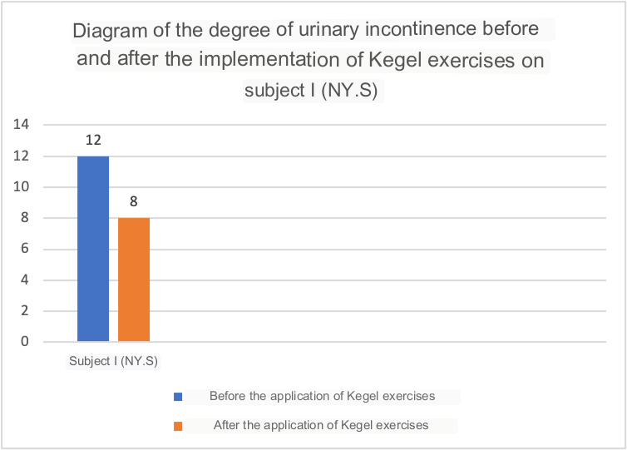
Diagram 1. Before and after Kegel exercises (Mrs. S)
Based on the diagram above, the degree of urinary incontinence in the subject (Mrs.S) before the application of Kegel exercises with a score of 12 and after the application of Kegel exercises decreased to a score of 8.
- The degree of urinary incontinence before and after the application of Kegel exercises subject II (Mrs.K)
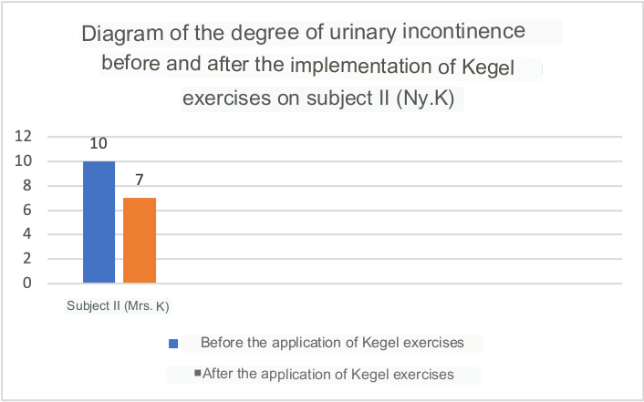
Diagram 2. Before and after Kegel exercises (Ny.K)

Based on the diagram above, the degree of urinary incontinence in the subject (Mrs.K) before the application of Kegel exercises with a score of 10 and after the application of Kegel exercises decreased to a score of 7. Based on the results of research on the application of kegel gymnastics conducted on Mrs.S and Mrs.K. It was found that the application of Kegel exercises was effective in reducing the degree of urinary incontinence in the elderly, where in subject I with a score of 12 (medium) to a score of 8 (light) and in subject II with a score of 10 (medium) to a score of 7 (light), This is in accordance with the theory of Widiastuti, (2011) which states that Kegel exercises are useful for strengthening skeletal muscles in the pelvic floor, thus strengthening the external sphincter in the bladder.
Based on the results of the study on both subjects, it was found that subject I was 69 years old and subject II was 70 years old, this is in accordance with the author's assumption that the trigger factor for urinary incontinence, where both subjects including the elderly who have begun to decline bladder function. This is in accordance with the theory of (Amelia, 2020) which states that urinary incontinence occurs in the elderly due to decreased bladder function and decreased muscle around the bladder. The results of the study on both subjects found that subject I with normal pregnancy and delivery 4 times and the second subject with a history of pregnancy and normal delivery 7 times, this is in accordance with the author's assumption that the trigger factor for urinary incontinence, where both subjects experienced the number of normal pregnancies and births as much as 4 and 7 times. This is in accordance with the theory of (Subandiyo, Widayanti, Riyadi, & Walin, 2022) which states that the number of normal pregnancy and childbirth events in women also affects pelvic floor muscle contractility due to stretching of the pelvic floor muscles and pudendal nerves due to intra-abdominal pressure for 9 months.
The results of the study before the application of Kegel exercises on the two subjects, the first subject, Mrs.S., said she could not hold urinating when kebelet, especially when coughing, sneezing and laughing out loud there was often urinary seepage, the second subject, Mrs.K said she could not hold urinating for more than 5 seconds when kebelet so that there was seepage before reaching the toilet, this is in accordance with the author's assumption that the symptoms of urinary icontinence suffered by both The subject was unable to hold urine when coughing, laughing, sneezing and unable to hold urine for more than 5 seconds. This is in accordance with the theory of (Agustina, Yuniarti, & Okhtiarini, 2021) yang menyatakan bahwa gejala inkontinensia urine yang sering ditemui pada lansia yaitu tidak dapat menahan kencing hingga ke toilet dan sering terdapat rembesan pada aktivitas yang mengakibatkan distensi pada abdomen seperti batuk, bersin dan tertawa.
The results of the study on both subjects, subject I said never traveled too far because of embarrassment could not hold urine, subject II said that difficulty sleeping because often urinating at night can be up to 6 times a night, this is in accordance with the author's assumption that the impact of urinary incontinence suffered by both subjects is social isolation and sleep disorders. This is in accordance with the theory of (Sulistyawati, Abdullah, Kasimbara, & Fau, 2022) which states that urinary incontinence experienced by the elderly will have an impact on other health problems such as sleep disorders to social isolation.

CONCLUSION
The application of Kegel exercises can reduce the degree of urinary incontinence in the elderly, where in subject I with a score of 12 (medium) to a score of 8 (light) and in subject II with a score of 10 (medium) to 7 (mild). The factors that influence the occurrence of urinary incontinence are age and number of partus, while the impact caused by urinary incontinence is social isolation and sleep disorders.

REFERENCES
Agustina, Anita, Yuniarti, Yuniarti, & Okhtiarini, Dina. (2021). HUBUNGAN TINGKAT DEPRESI DENGAN KEJADIAN INKONTINENSIA URINE PADA LANSIA DI PANTI SOSIAL TRESNA WERDHA BUDI SEJAHTERA BANJARBARU. Jurnal Terapung: Ilmu-Ilmu Sosial, 3(2), 1–12.
Amelia, Rinita. (2020). Prevalensi dan Faktor Risiko Inkontinensia Urin pada lansia Panti Sosial Tuna Werdha (PSTW) Sumatera Barat. Health & Medical Journal, 11, 39–44.
Harahap, Mei Adelina, & Rangkuti, Nur Aliyah. (2020). Pengaruh Senam Kegel Terhadap Frekuensi Inkontinensia Urine pada Lansia di Wilayah Kerja Puskesmas Pijorkoling Kota Padangsidimpuan. Jurnal Education and Development, 8(4), 523.
Karjoyo, Julianti Dewi, Pangemanan, Damayanti, & Onibala, Franly. (2017). Pengaruh Senam Kegel Terhadap Frekuensi Inkontinensia Urine Pada Lanjut Usia Di Wilayah Kerja Puskesmas Tumpaan Minahasa Selatan. Jurnal Keperawatan, 5(1).
Kemenkes, R. I. (2018). Hasil riset kesehatan dasar tahun 2018. Kementrian Kesehatan RI, 53(9), 1689–1699.
LIDYA, NOVITA SARI. (2022). ASUHAN KEPERAWATAN GERONTIK PADA NY. S DENGAN DIAGNOSIS HIPERTENSI DI UPTD GRIYA WREDA JAMBANGAN SURABAYA. STIKES HANG TUAH SURABAYA.
Novera, Milya. (2017). Pengaruh Senam Kegel Terhadap Frekuensi Bak Pada Lansia Dengan Inkontinensia Urine. Jurnal Ipteks Terapan, 3, 241.
Organization, World Health. (2015). Definition of an older or elderly person. 2010 http://www. who. int/healthinfo/survey/ageingdefnolder/en. Accessed.
Priambodo, Nanda Dwi Satrio. (2020). Asuhan Keperawatan Gerontik Dengan Defisit Pengetahuan Pada Klien Hipertensi Di Desa Balung Tawun Kecamatan Sukodadi Kabupaten Lamongan. UNIVERSITAS AIRLANGGA.
Purnomo, B. (2014). Urologi. CV Sagung Seto.
Rani, H. A., Isya, M., & Chalid, A. (2019). The identification of the most dominant contractor’s performance factor influencing the road preservation quality achievement using long segment. AIP Conference Proceedings, 2059(1). AIP Publishing.
Relida, Nova, & Ilona, Yulia Tetra. (2020). Pengaruh pemberian senam kegel untuk menurunkan derajat inkontinensia urin pada lansia. Jurnal Ilmiah Fisioterapi, 3(1), 18–24.
Stanley, Mickey, & Beare, Patricia Gauntlett. (2006). Buku ajar keperawatan gerontik. Jakarta: Egc.
Subandiyo, Subandiyo, Widayanti, Esti Dwi, Riyadi, Sugeng, & Walin, Walin. (2022). LATIHAN SENAM KEGEL DENGAN PENURUNAN INKONTINENSIA URIN PADA LANSIA DI POSYANDU LANSIA WIRASANA PURBALINGGA. Martabe: Jurnal Pengabdian Kepada Masyarakat, 5(3), 1050–1057.
Sulistyawati, Aulia Ika, Abdullah, Ahmad, Kasimbara, Rachma Putri, & Fau, Yohanes Deo. (2022). Pengaruh Latihan Senam Kegel Terhadap Inkontinensia Urine Pada Lansia Di RS Toeloengredjo Pare. Jurnal Keperawatan Muhammadiyah, 7(1).
Wahyudi, Agus Setyo, Sulastri, S. Kp, & Jadmiko, Arif Wahyudi. (2017). Pengaruh latihan senam kegel terhadap frekuensi berkemih pada lansia. Universitas Muhammadiyah Surakarta.
Widiastuti, P. N. (2011). Latihan Kegel Dengan Penurunan Gejala Inkontinensia Urin Pada Lansia.

